Dots and boxes planning document

# Description

The game is played on a rectangular grid of dots. Players alternate in taking turns. On a turn a player draws a horizontal or vertical line connecting two adjacent dots (not previously connected). If a player succeeds in completing a box of 4 adjacent dots, that player Owns that box and may take another turn. The game ends when all boxes on the board are owned. The objective is to own more boxes than the opponent at the end of the game.

# Screenshot

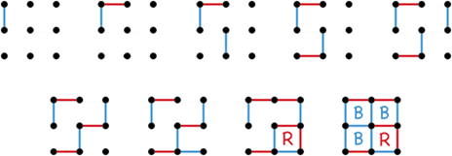

# Milestones

1. Display a grid of dots. -- done
2. User click and drag, display a rubber band line. -- done
3. Make rubberband line snap to dot locations - done
4. Allow a user to click, drag and release to connect dots. -- done
5. Alternate turns showing connections in red and blue. -- done
6. When a box is complete label it with the appropriate letter. -- done
7. Show who won at end of game (SCORE) -- done
8. Create a smart AI to play against.
   1. If there are boxes with 3 lines, pick one at random and close it.
   2. If there are boxes with fewer than 2 lines pick one at random
   3. Otherwise just pick any random spot

# Class Diagram

MousePress() - store the press location

Mouse Release()

Determine the two dots that are being connected

If any line in the set already has those two dots quit and do nothing

Create a line and add it to the set of lines

Determine the boxes this line belongs to

Add this line to those boxes.

If any of those boxes are now closed apply the label and add to the score

If all of the boxes are now closed Game Over announce winner

